DATA STRUCTURE
Elementary Data Organization

Data:- data can be defined as a representation of facts, concepts or instructions in a formalized manner suitable for communication, interpretation or processing by human or electronic machine.

Data is represented with the help of characters like alphabets(A-Z , a-z), digits(0-9) or special character(+,-,*,&,? Etc.) . Data may be a single value or it may be a set of values, must be organized in a particular fashion.
Data Item:- A set of characters which are used together to represent a specific data element e.g. name of a student in a class is represented by the data item NAME.
Types of data items:-

- Elementary data items:- these data items can not be further sub divided. For exp. SID

- Group data items:- These data items can be further sub-divided into elementary data items. For example Date. Date may be divided into days, months and years.
- Record:- record is a collection of related data

items e.g. a payroll record for an employee

contains data fields such as name, age,

qualification, sex, basic pay, DA, HRA, PF etc.

File:- File is a collection of logically related records e.g. a payroll file might consist of the employee pay records for a company.

Introduction to Data Structure

Definition

Data Structure is a representation of the logical

relationship existing between individual elements

of data.

Or

A Data structure is a way of organizing all data items

that considers not only the elements stored but also their relationship to each other.

Data structure mainly specifies the following four things:-

- Organization of data

- Accessing methods

- Degree of associativity

- Processing alternatives for information
Classification of Data Structure

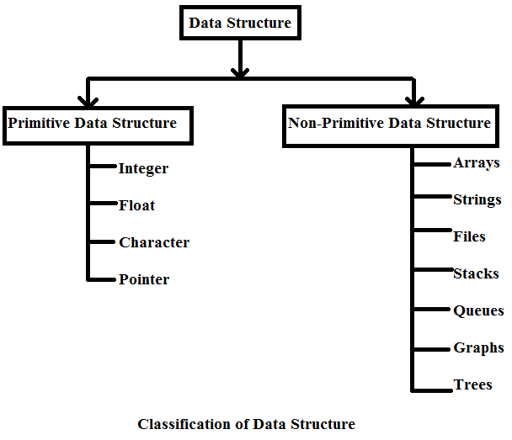
Primitive Data Structure :- The data structure that are

atomic or indivisible are called primitive. Example are

integer, real, float, Boolean and characters.

Non-Primitive data structure :- The data structure that are not atomic are called non primitive or composite. Examples are records, arrays and strings. These are more sophisticated. The non primitive data structures

emphasize on structuring f a group of homogenous or

heterogeneous data items.

- Linear Data Structure :- In a linear data structure, the data items are arranged in a linear sequence. Example is array.

Non Linear data structure :- In a non-linear

data structure, the data items are not in

sequence. Example is tree.
- Homogenous Data Structure :- In homogenous data structure, all the elements are of same type. Example is array.

Non Homogenous Data Structure :-in non-homogenous structures, all the elements are may or may not be of the same types. Example is records.

Static Data Structure :- Static structures are ones whose sizes and structures, associated memory location are fixed at compile time.

Dynamic Data Structure :- Dynamic structures are

ones which expand or shrink as required during the

program execution and there associate memory

location change.

Arrays:- An array is defined as a set of finite

number of homogenous elements or data

items. It means an array can contain one type

of data only, either all integers, all floating point

numbers or all characters.3

Exp:- int a[10]

Concepts of array:

- The individual element of an array can be accessed by specifying name of the array, followed by index or subscript inside square bracket.

Exp. to access the 10th element statement will be a[9].

- The first element of the array has index zero[0]. So in an array of 10 elements the first array will be a[0] and last a[9]

- The elements of array will always be stored in consecutive memory location.
- The size of an array can be calculate by this equation

(upper bound- lower bound )+1 (9-0)+1

- Arrays can always be read or written through loop. In case of one dimensional array it required one loop for reading and one loop for writing and in case of two dimensional array it requires two loops for each operation.
Operation performed on array

- Creation of an array

- Traversing of an array

- Insertion of new elements

- Deletion of required elements

- Modification of an element

- Merging of arrays

Lists:- A list can be defined as a collection of

variable number of data items. List are the most

commonly used non-primitive data structures.

An element of list must contain at least two

fields, one for storing data or information and

other for storing address of next element.
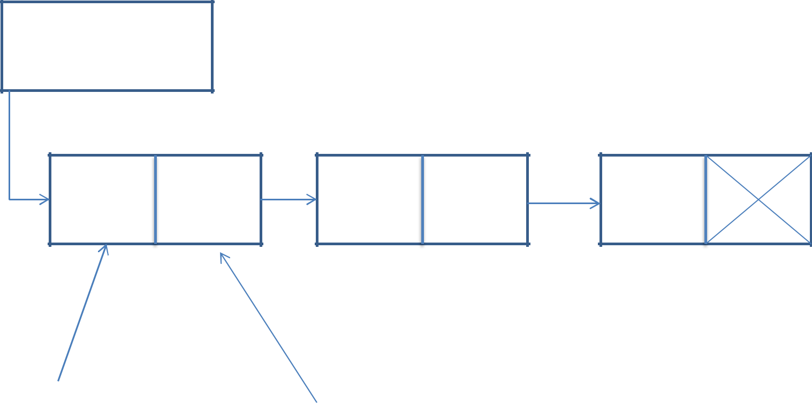
Head

aman | neha | riya

Information | Pointer Field
Field | Pointer Field

Stack :- A stack is also an ordered collection of elements like array but it has a special feature that deletion and insertion of elements can be done only from one end, called the top of the stack.It is a non primitive data structure.

- It is also called as last in first out type of data structure(LIFO).

- Exp. Train, stack of trays etc.

- At the time of insertion or removal of an element base of stack remains same.

- Insertion of element is called Push

- Deletion of element is called Pop
Stack implementation

- Static implementation (using array)

- Dynamic implementation(using pointer)

Queue :- Queues are first in first out type of

data structures. In a queue new elements are

added to the queue from one end called rear

end and the elements are always removed from

other end called the front end.

10 30 70 80 90 95 97
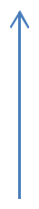

Front Rear

- New elements are added to the queue from one end called REAR end

- Elements are always removed from other end called front end

- Exp. : queue of railway reservation.

- FIFO

Queue Implementation

- Static implementation (using array)

- Dynamic implementation(using pointer)

